Programming Fundamentals Lab

Lab Assignment 07

Course Code: CL1002

Syed Muhammad Shuja Ur Rahman

Roll No. 22K-4456

**Task 01**

You are responsible for the logistics of various types of cargo. Depending on the weight of each

cargo, you need a different vehicle, and this will cost a different price per ton:

1. Up to 3 tons – a minibus ($200 per ton).
2. From over 3 and up to 11 tons – truck ($175 per ton).
3. Over 11 tons – train ($120 per ton).

Your task is to calculate the average price per ton of the cargo, and also what percentage of the

cargo is transported in each vehicle.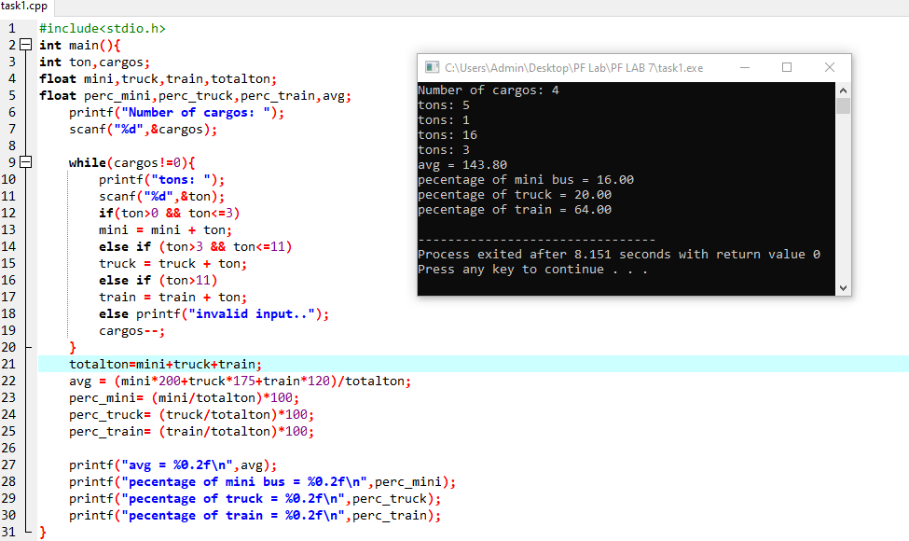

**Task 02**

For a certain period of time, patients arrive at the hospital every day for an examination. It has

initially 7 doctors. Each doctor can treat only one patient per day, but sometimes there is a

shortage of doctors, so the remaining patients are sent to other hospitals. Every third day the

hospital makes calculations and if the count of untreated patients is greater than the count of

treated ones, another doctor is appointed.

Write a program, that calculates for a given period of time, the count of treated and untreated

patients.

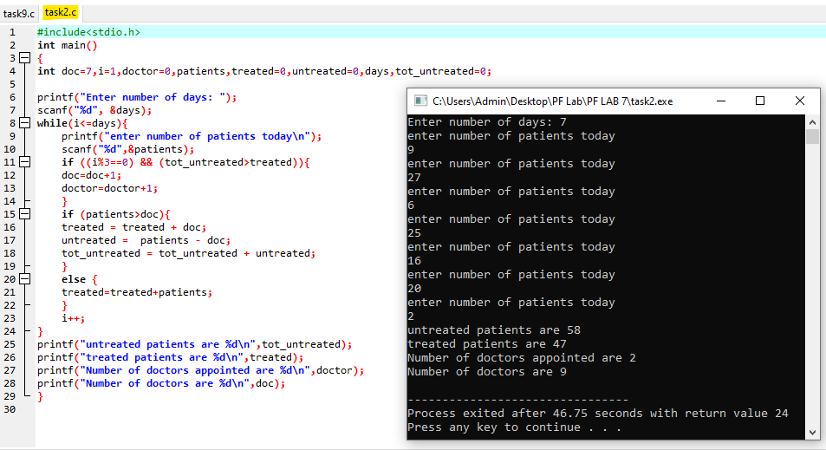

**Task 03**

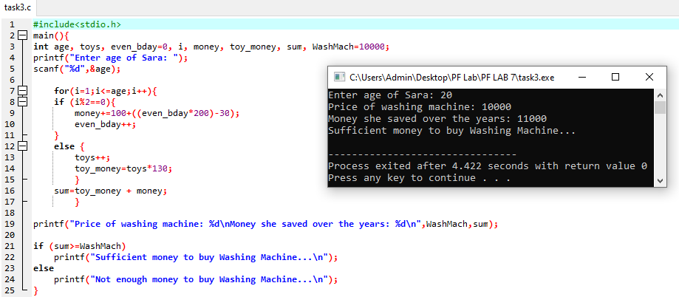Sara is N years old. For each birthday she receives a present. For each odd birthday (1, 3, 5, ..., n) she receives toys, and for each even birthday (2, 4, 6, ..., n) she receives money. For her second birthday she received Rs. 100, and the amount is increased by Rs 200 for each following even birthday. Over the years Sara has secretly saved her money. Sara's brother, in the years when she received money, took Rs. 30 from each of the amounts. Sara has sold the toys, received over the years, each one for Rs. 130 USD and added the sum to the amount of saved money. With the money she wanted to buy a washing machine for Rs 10,000. Write a program that calculates how much money she has saved and if it is enough to buy a washing machine.

**Task 04**

We have n integer numbers within the range of [1 ... 1000]. Some percent of them p1 are under 200, another percent p2 are from 200 to 399, percent p3 are from 400 to 599, percent p4 are from 600 to 799 and the rest p5 percent are from 800 upwards. Write a program that calculates and prints the percentages p1, p2, p3, p4 and p5.

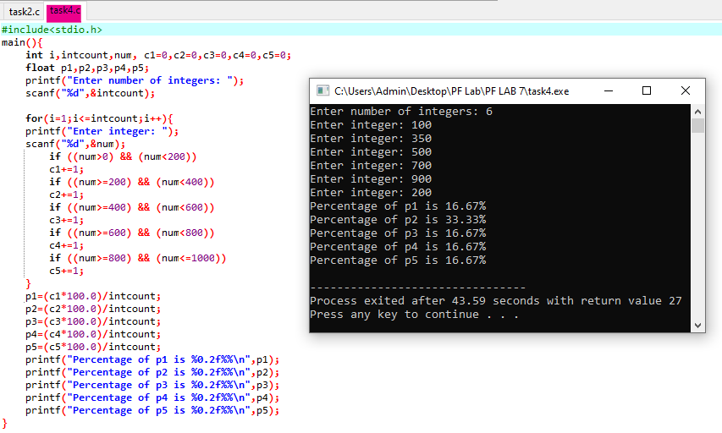

**Task 05**

The factorial of n (written n!) is the product of the integers between 1 and n. Thus 4! = 1*2*3*4 = 24 or 4! = 4*3*2*1 = 24. By definition, 0! = 1. Factorial is not defined for negative numbers. Write a program that asks the user for a non-negative integer and computes and prints the factorial of that integer. You will need to perform the following tasks.

1. Your program should check to see if the user entered a negative number. If so, the program should print a message saying that a nonnegative number is required and ask the user the enter another number. The program should keep doing this until the user enters a nonnegative number, after which it should compute the factorial of that number.

2. You can use any loop you like to calculate the factorial.

3. Your program should also check what should happen if the user enters 0.

4. Your output should be in the following format.

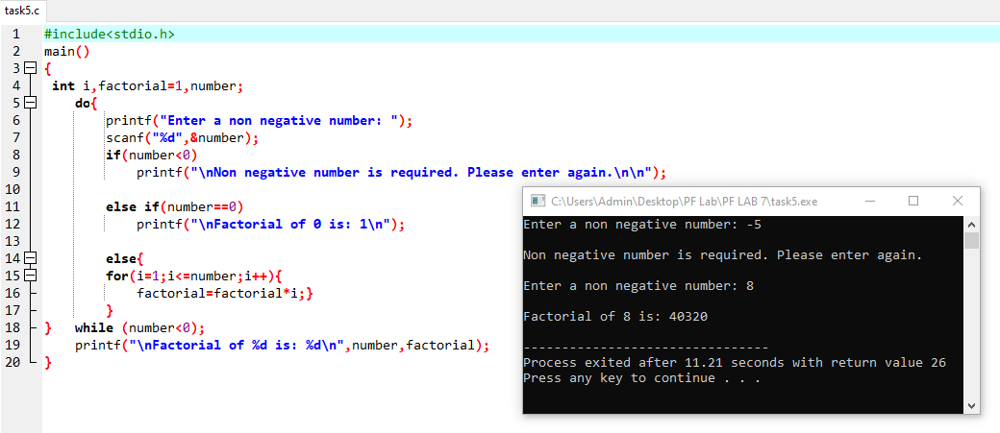

**Task 06**

Ali is 18 years old and receives an inheritance that consists of Rs. 2,00,000. He decides to return Rs. 1,00,000, but does not know if the left money will be enough to live without working for 5 years. Write a program that calculates if Ali will have enough money to not have to work for 5 years. Assuming that for every even year he will spends Rs. 25,563. For every odd year he spends (even year + 12,580).

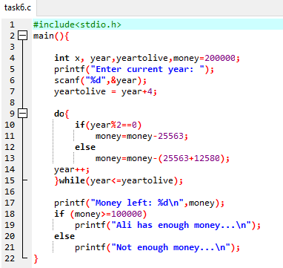

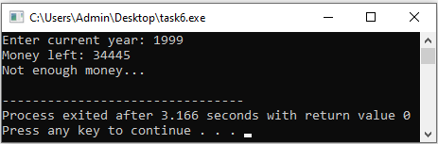

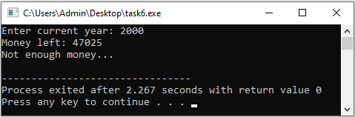

**Task 07**

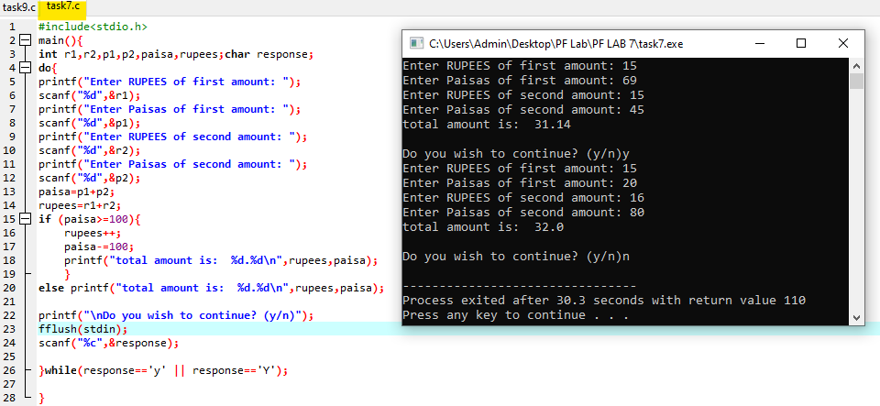Write a program that repeatedly asks the user to enter two money amounts expressed in Rupees and Paisas. The program should then add the two amounts and display the answer, again in Rupees and Paisas. Use a do while loop that asks the user whether the program should be terminated.

**Task 08**

File Guess.c below contains a skeleton for a program to play a guessing game with the user. The program randomly generates an integer between 1 and 10, then ask the user to try to guess the number. If the user guesses incorrectly, the program should ask them to try again until the guess is correct; when the guess is correct, the program should print a congratulatory message.

1. Using the comments as a guide, complete the program so that it plays the game as described above.

2. Modify the program so that if the guess is wrong, the program says whether it is too high or too low. You will need an if statement (inside your loop) to do this.

3. Now add code to count how many guesses is remaining to the user to get the number, and print this number at the end with the congratulatory message. (You can give user 3 chances to guess)

4. Finally, count how many of the guesses are too high and how many are too low. Print these values, along with the total number of guesses, when the user finally guesses correctly.

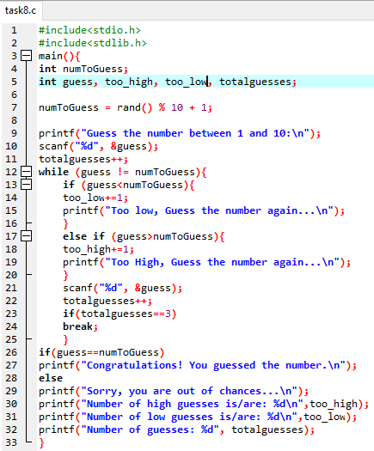

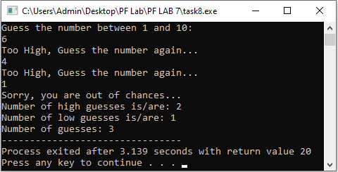

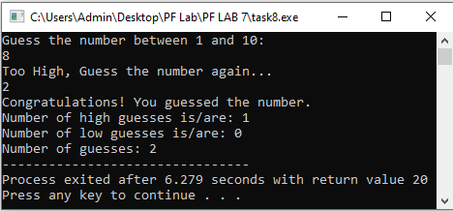

**Task 09**

It's almost election day and the election officials need a program to help tally election results. There are two candidates for office — Candidate A and Candidate B. The program's job is to take as input the number of votes each candidate received in each voting district and find the total number of votes for each. The program should print out the final tally for each candidate— both the total number of votes each received and the percent of votes each received. You should perform the following tasks;

1. Add the code to control the loop. You may use either a while loop or a do...while loop. The loop must be controlled by asking the user whether or not there are more districts to report (Consider there are 7 districts (D1, D2, D3, D4, D5, D6, D7) in which the elections are being held). The user should answer with the character y or n though your program should also allow uppercase responses.

2. Add the code to read in the votes for each candidate and find the total votes. Print out the total number of votes from all districts and the percentages.

3. Also display the number of votes both candidates got from each districts with percentages.

4. The election officials want more information. They want to know how many districts each candidate won. Add code to compute and print this. You need three new variables: one to count the number of districts won by Candidate A, one to count the number won by Candidate B, and one to count the number of ties.

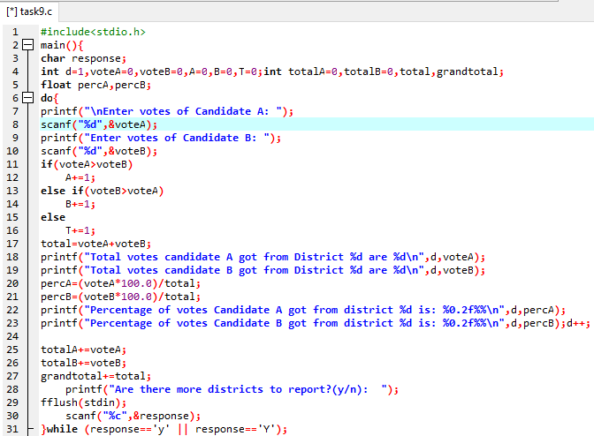

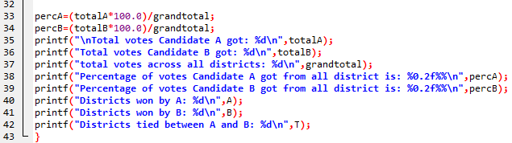

**OUTPUT ON NEXT PAGE**

